Nama : Dimas Shofa Gunarso

NIM : 18090061

Kelas : 5D

Praktikum 1

1. Source Code

Perkenalan.php -> aplication/controller

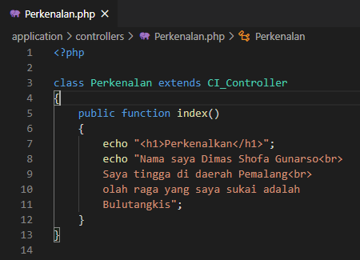

1. Hasil URL

[http://localhost//pustaka-booking/index.php/Perkenalan/](http://localhost//pustaka-booking/index.php/Perkenalan/%20)

1. Capture Hasil

